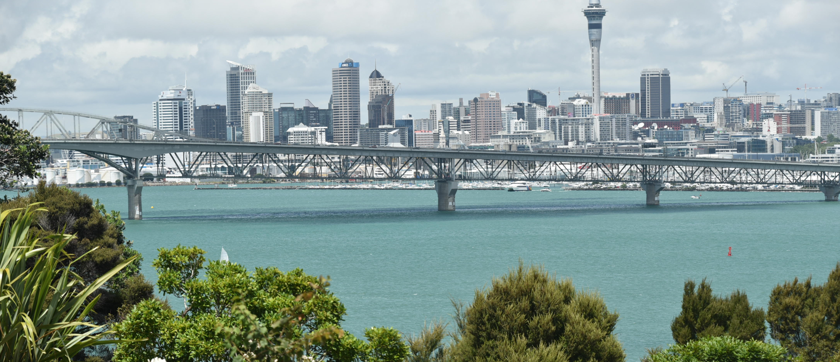
Brett Higginson Location Scout Ph. +64 (0) 27 488-9868 aucklandfilmlocations@gmail.com
http://www.imdb.com/name/nm2759747/

I’ve been in the NZ film industry since the early 90’s and have worked on over 40 movies / TV series, and on hundreds of TV commercials. I am Auckland based, with extensive nationwide contacts and I have over 8,000 locations in my library.
I’m a hard working person who delivers… A brief bio:

Production Company Position
Hunt For The Wilderpeople Piki Films Location Scout
Power Rangers – Ninja Steel Power Rangers Ltd Location Scout
The Making of the Mob: Chicago Stephen David Entertainment Location Scout
The Rehearsal Rehearsal Films Location Scout
Dirty Laundry Filthy Productions Location Scout
6 Days GFC Location Scout
Crouching Tiger, Sword Of Destiny Weinstein Company Location Scout
Mahana The Patriarch Ltd Location Scout
Filthy Rich Filthy Productions Location Scout
Ash vs Evil Dead Starz Location Scout
Tatau BBC / SPP Location Scout
Lumen Dreamworks Location Scout
The Brokenwood Mysteries South Pacific Pictures Location Scout
Nothing Trivial South Pacific Pictures Location Scout
Emperor Corn Cob Ltd Location Scout
Yogi Bear Warner Bros Location Manager Chronicles of Narnia Prince Caspian Walden Media Location Scout
Bride Flight IDTV Film Location Manager
Bridge To Terabithia Walden Media Location Scout
Without A Paddle Paramount Pictures Location Scout
In My Fathers Den T.H.E Films Location Scout
Rain Rain Films Location Manager

